UCS2611 – Internet Programming Lab

------------------------------------------------------------------------------------

**Mini project Description**

Develop a full stack web application for conducting *On-line quiz using MVC architecture*. The application should facilitate the normal and admin users to access it. To the normal user, instructions, questions with options and the score needs to be provided as the following snapshots. Admin user can view the registered users and their scores.

Design the following:

* Schema of the necessary MongoDB collections. One of which is shown below
  + Create Questions collection in MongoDB as follows to store the information about the students and Questions with choices.

|  |  |  |  |  |  |
| --- | --- | --- | --- | --- | --- |
| Question | Choice_A | Choice_B | Choice_C | Choice_D | Answer |

* Design the application with the necessary endpoints, controllers, collections, and components as a sequence diagram

Do the following operations:

* Authenticate the user and provide necessary messages
* Keep a timer for the Quiz
* Sending appropriate GET http requests from front end, to the endpoint in the node server.
* Perform necessary operations in the Mongo Collection at the endpoints
* Create a suitable interface in ReactJS to display the results

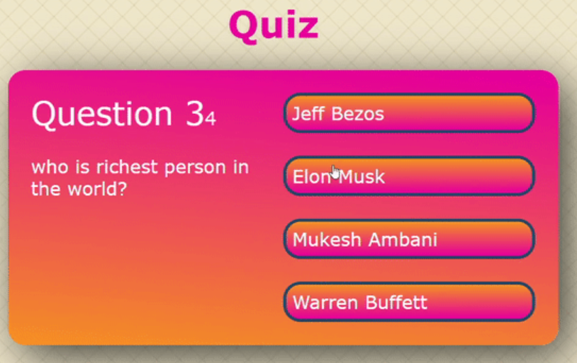

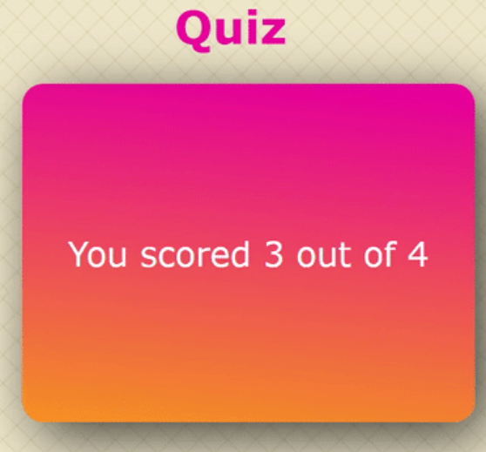

Use the following Best Practices:

* Design before coding
* Incremental coding
* Usage of proper naming convention
* Usage of Comments to the code
* Indentation of code